3.3.3.3.6 Tessellation
# Source: AI Source: Provided by: [Data Path: Persons Table -> ID Column: 1, Name_En Column: Motasem Essam] -> From: [ChatGPT] on [7/25/2026]
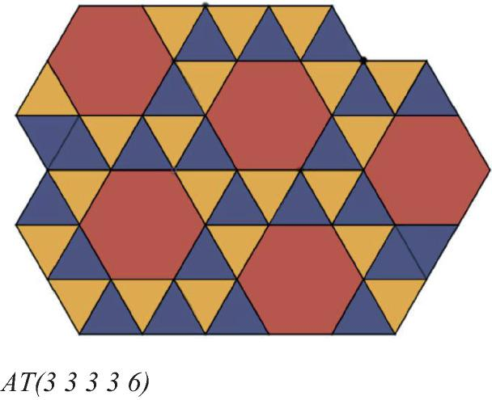
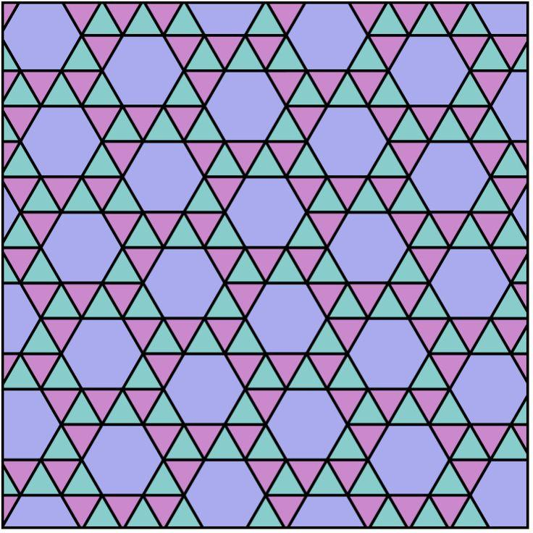
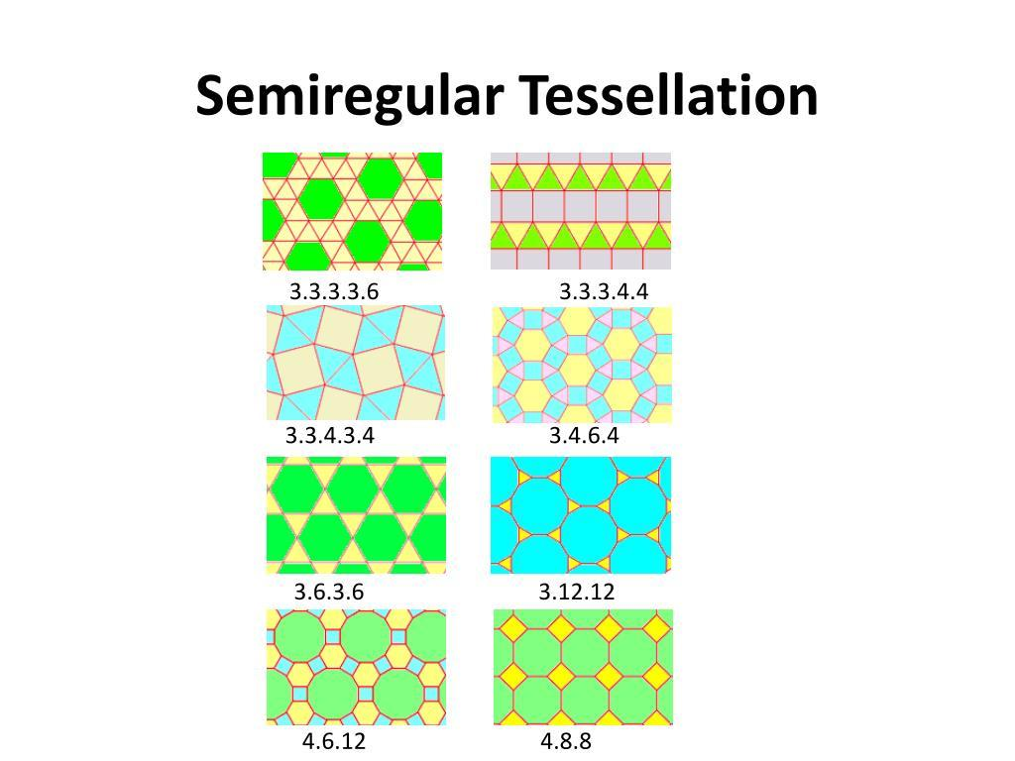

Definition
# Source: AI Source: Provided by: [Data Path: Persons Table -> ID Column: 1, Name_En Column: Motasem Essam] -> From: [ChatGPT] on [7/25/2026]
The $3.3.3.3.6$Tessellation is a semi-regular (Archimedean) tessellation composed of equilateral triangles and regular hexagons.
The vertex configuration
$$\boxed{3.3.3.3.6}$$
means that, around every vertex, there are:
- Four equilateral triangles
- One regular hexagon
in that cyclic order.

Vertex Configuration
# Source: AI Source: Provided by: [Data Path: Persons Table -> ID Column: 1, Name_En Column: Motasem Essam] -> From: [ChatGPT] on [7/25/2026]
$$\boxed{3.3.3.3.6}$$
The numbers represent the number of sides of the polygons meeting at each vertex:
3 → 3 → 3 → 3 → 6
Therefore:
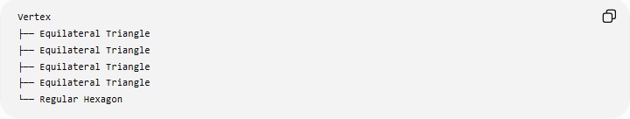
Vertex
├── Equilateral Triangle
├── Equilateral Triangle
├── Equilateral Triangle
├── Equilateral Triangle
└── Regular Hexagon

Angle Verification
# Source: AI Source: Provided by: [Data Path: Persons Table -> ID Column: 1, Name_En Column: Motasem Essam] -> From: [ChatGPT] on [7/25/2026]
An equilateral triangle has interior angle:
$${60}^{∘}$$
A regular hexagon has interior angle:
$${120}^{∘}$$
Therefore, around each vertex:
$${60}^{∘}+{60}^{∘}+{60}^{∘}+{60}^{∘}+{120}^{∘} \\ ={240}^{∘}+{120}^{∘} \\ \boxed{={360}^{∘}}$$
Thus, the polygons fit exactly around every vertex.

Fundamental Elements
# Source: AI Source: Provided by: [Data Path: Persons Table -> ID Column: 1, Name_En Column: Motasem Essam] -> From: [ChatGPT] on [7/25/2026]
Equilateral Triangle
Each triangle has:
$$\boxed{{60}^{∘}}$$
at every vertex.
Regular Hexagon
Each hexagon has:
$$\boxed{{120}^{∘}}$$
at every vertex.
Vertex
Five polygons meet at every vertex:
$$\boxed{4\text{ triangles}+1\text{ hexagon}}$$

Why It Is Semi-Regular
# Source: AI Source: Provided by: [Data Path: Persons Table -> ID Column: 1, Name_En Column: Motasem Essam] -> From: [ChatGPT] on [7/25/2026]
It is not regular because it uses two different types of regular polygons:
$$\boxed{\text{Triangle}+\text{Hexagon}}$$
It is semi-regular because:
- Every tile is a regular polygon.
- The same vertex configuration $3.3.3.3.6$occurs at every vertex.
- The polygons fit without gaps or overlaps.

Polygon Composition
# Source: AI Source: Provided by: [Data Path: Persons Table -> ID Column: 1, Name_En Column: Motasem Essam] -> From: [ChatGPT] on [7/25/2026]
The tessellation contains:
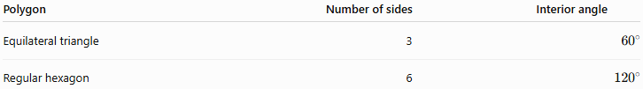
Polygon | Number of sides | Interior angle
Equilateral triangle | 3 | $${60}^{∘}$$
Regular hexagon | 6 | $${120}^{∘}$$
At each vertex:
$$\boxed{4\left(3\text{-gons}\right)+1\left(6\text{-gon}\right)}$$

Symmetry
# Source: AI Source: Provided by: [Data Path: Persons Table -> ID Column: 1, Name_En Column: Motasem Essam] -> From: [ChatGPT] on [7/25/2026]
The $3.3.3.3.6$tessellation has:
- Translational symmetry
- Rotational symmetry
- Reflection symmetry
It is therefore a periodic tessellation.
So it can be classified simultaneously as:
$$\boxed{\text{Semi-Regular + Periodic}}$$

Relationship to Other Tessellations
# Source: AI Source: Provided by: [Data Path: Persons Table -> ID Column: 1, Name_En Column: Motasem Essam] -> From: [ChatGPT] on [7/25/2026]
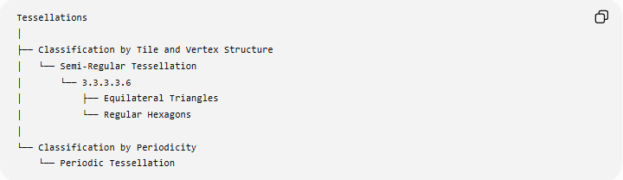
Tessellations
│
├── Classification by Tile and Vertex Structure
│ └── Semi-Regular Tessellation
│ └── 3.3.3.3.6
│ ├── Equilateral Triangles
│ └── Regular Hexagons
│
└── Classification by Periodicity
└── Periodic Tessellation

Comparison with $3.6.3.6$
# Source: AI Source: Provided by: [Data Path: Persons Table -> ID Column: 1, Name_En Column: Motasem Essam] -> From: [ChatGPT] on [7/25/2026]
Both use equilateral triangles and regular hexagons, but their vertex configurations are different.
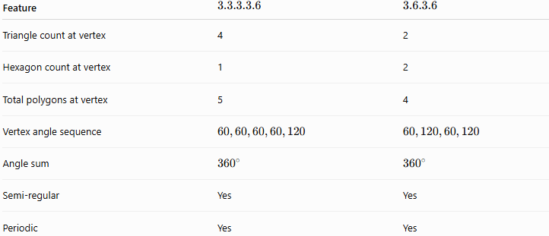
Feature | $$3.3.3.3.6$$ | $$3.6.3.6$$
Triangle count at vertex | 4 | 2
Hexagon count at vertex | 1 | 2
Total polygons at vertex | 5 | 4
Vertex angle sequence | $$60,60,60,60,120$$ | $$60,120,60,120$$
Angle sum | $${360}^{∘}$$ | $${360}^{∘}$$
Semi-regular | Yes | Yes
Periodic | Yes | Yes
The order of polygons around the vertex matters, so $3.3.3.3.6$and $3.6.3.6$are distinct tessellations.

Key Points
# Source: AI Source: Provided by: [Data Path: Persons Table -> ID Column: 1, Name_En Column: Motasem Essam] -> From: [ChatGPT] on [7/25/2026]
$$\boxed{3.3.3.3.6}$$
- Uses equilateral triangles and regular hexagons.
- Four triangles and one hexagon meet at every vertex.
- The angles are:
$${60}^{∘},{60}^{∘},{60}^{∘},{60}^{∘},{120}^{∘}$$
- Their sum is:
$$\boxed{{360}^{∘}}$$
- It is a semi-regular (Archimedean) tessellation.
- It is also periodic.
- Its vertex configuration is uniquely:
$$\boxed{3.3.3.3.6}$$

